**Compliance Patterns Using LTL Checker in PROM: Testing with BPI2013 Log**

1. Alternate Response:

1. A screenshot of a computer

   AI-generated content may be incorrect.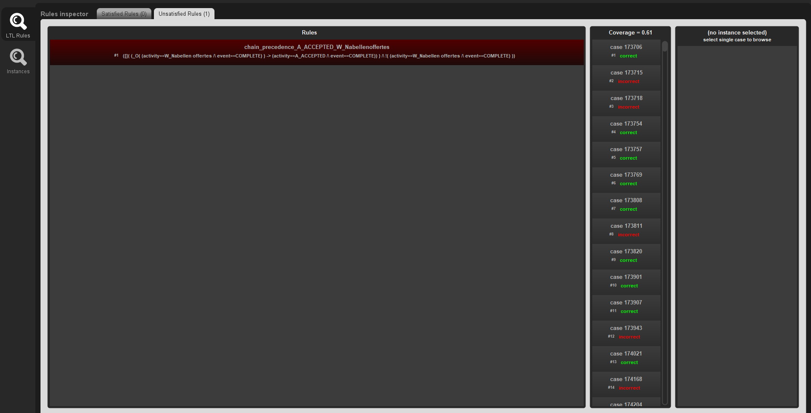Chain Precedence:
2. Chain Response

1. Responded Existence:

1. A screenshot of a computer

   AI-generated content may be incorrect.Absence:
2. A screenshot of a computer

   AI-generated content may be incorrect.Existence: